**Leader Overview**

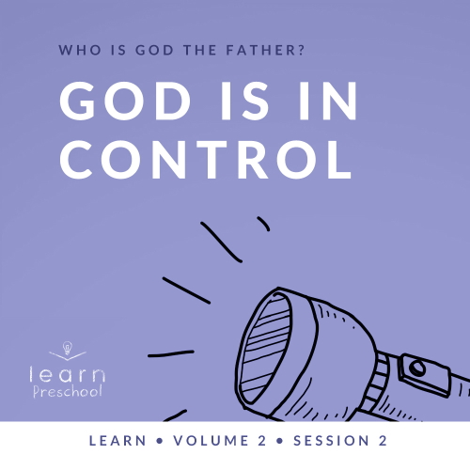

**Volume Overview**

**Who is God the Father?**

*God the Father chose to reveal who He is throughout His Word. A robust picture of God can be seen by looking at His interactions with men and women like us. Since people first sinned in* [*Genesis 3*](https://ref.ly/logosref/Bible.Ge3)*, every generation has had to connect with our invisible God for themselves. Through these sessions about God, you have the opportunity to pass on this life-changing relationship to kids*.

**Session Overview**

**God Is in Control**

*In this* **Learn** *session, preschoolers will discover that they can trust God’s plans for their life because He is in control. Throughout the Old Testament, we see God display His power and authority. In today’s Bible story, a potter shapes clay into a jar. In the same way, our God can shape us. Preschoolers will learn that they can trust God because He made them*.

**Bible Lesson**

God Is the Potter

[Jeremiah 18:1–11](https://ref.ly/logosref/Bible.Je18.1-11)

**Faith Fact**

My God is in control.

**Faith Verse**

[Isaiah 55:8](https://ref.ly/logosref/Bible.Is55.8) (NLT)

“My thoughts are nothing like your thoughts,” says the Lord. “And my ways are far beyond anything you could imagine.”

**Preparing for the Session**

**Leader Preparation Time: 20–25 Minutes**

|  |
| --- |
| ***You Will Need***  ***Preservice Activities***   * *Pipe cleaners, various colors* * *Snack options, three or four options*   ***Large Group***   * *Bible* * *Worship songs (Song suggestions: “You Are My God,” KidSpring Children’s Ministry; “Special,” ElevateKids; “You Are Awesome,” Bible Adventure Worship)* * *For groups not using a phone or tablet only, add:*   *• Projector or TV*  *• Laptop*  *•* ***Faith Fact Sound video*** *(bell ringing)*  *•* ***Faith Fact Slide***  ***• Faith Verse Slide***  ***• Bible Lesson Video A***  ***• Bible Lesson Video B***  ***Small Group***   * *Blank paper, one sheet per kid plus extra* * *Markers or crayons* * ***Small Group Activity Page****, one per kid* * *Painter’s tape or other floor-safe tape* * *Cones or floor markers* * *Play dough for each kid*   *To access session content and videos from a computer, visit:* [*BibleEngagementProject.com/downloads*](https://bibleengagementproject.com/Downloads) |
| ***Getting Ready***  ***Preservice Activities***   * *Set out toys and snacks.*   ***Large Group***   * *Download videos and slides if needed.* * *Select worship song(s) and have them ready to play.*   ***Small Group***   * *Have a simple picture in mind for kids to draw (flower, stick figure, etc.).* * *Draw the picture to display to kids when they open their eyes.* * *Print copies of the Small Group Activity Page, one per kid.* * *Tape lines across the floor. Have one line that makes it all the way across the room and several that dead end. Have cones at the start and end of the maze so kids know where the finish line is.*   *First time leading* Learn *for Preschool? Check out the* [*Facilitator Guide*](https://0b769b0ed3569ef9d18b-f88d8272f61086866d50d048b43ef630.ssl.cf2.rackcdn.com/sites/biblengagementproject/Listen_Facilitator_Guide.pdf)*.* |

**Preservice Activities**

*See what’s needed at the beginning of the session.*

**Bible Story Warm-Up**

Today, I have so much fun planned for you as we learn more about God. Raise your hand if you’re excited to learn about God today. *(Group response)* I love God so much, and I love getting to learn more about Him with you. Did you know that God made you? (*Group response)* That’s pretty amazing that God made us. Today, we’ll talk about making things, so right now I want you to take some pipe cleaners and bend them until you make something special.

• *Give kids the pipe cleaners and allow a few minutes for kids to create their items*.

• *Ask questions that introduce the Bible story and theme*.

What do you like to use at home to make things?

Have you ever tried building or drawing something, but it didn’t turn out how you wanted it to?

What did you do when that happened to you?

• *As kids finish their creations, ask them to share what they made*.

Wow! You’re so creative! Does anyone want to show us what you made? *(Allow responses.)* You know what’s really great? You knew exactly what you made, and how it should work or what it should do. You were in control of it. That’s like God. He’s strong enough to control what He creates, too. Do you know who He created? *(Group response)* He created each of you. We’ll talk more about this in our Bible story today.

**Snack**

**Snack Choices**

If you could pick any snack to have, what would you pick? *(Allow responses.)* Woah! Those sound pretty yummy. Today, you get to have control of what snack you eat. You have these options to choose from. *(List options.)* Which snack will you choose?

• *Allow kids to pick a snack and eat it*.

Sometimes we don’t have control over things in our life. Has someone ever made a meal for you and put something in it that you didn’t like? *(Group response)* Was it something that was healthy for you? *(Group response)* Sometimes we need to eat healthy foods even though they may not be our favorite. We don’t have control over what foods our body needs to grow big and strong. God created our body to need certain foods. We can trust God because He created us and knows what is best for us.

**Free Play**

*Any extra time can be spent playing with toys*.

**Transition**

*A few minutes before service begins have kids make their way to the large group area and sit in their designated areas*.

**Large Group**

**25 Minutes**

*See what’s needed at the beginning of the session.*

**Introduction**

It’s so good to be with you, my friends! I’m so excited that you’re here today. In fact, I could hardly wait to get to hang out with you. If you’re excited to be here today, clap your hands three times. *(Group response)*

**Faith Fact**

Today, we’re going to talk about control, so we’re going to pretend that I have a remote control. *(Hold pretend remote in hand.)* I’m going to control how we say our Faith Fact: **My God is in control**.

• *Show the* ***Faith Fact Slide.***



Make sure to have your listening ears on so you know exactly how to say it. Here we go. Let’s say it in slow motion. *(Pretend to press remote.)* **My God is in control**.

Great job! Now, let’s fast forward and say it as fast as we can. *(Pretend to press remote.)* **My God is in control**. Whew! You’re so good at this. Let me turn the volume up, and let’s do it as loud as we can. *(Pretend to press remote.)* **My God is in control**.

**Bible Time**

You did a great job letting me be in control. It’s not always easy to let someone else be in charge. Did you know the Bible talks about that? *(Group response)* Our Faith Verse reminds us that God knows so much more than we do. That’s why we should choose to let Him be in control. Let’s check in with Lizzy.

• *Play* ***Bible Lesson Video A***.

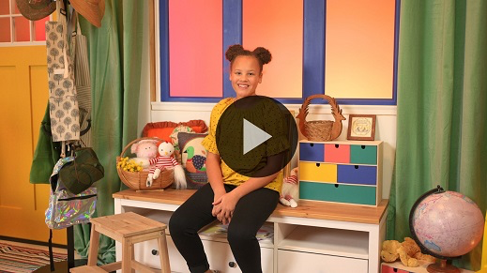

**Worship**

I love hearing you say our Faith Verse. Every time we learn a new Faith Verse, it helps us focus on who God is. I get so excited learning about God because I love Him so much. Who loves God? Raise your hand*. (Group response)* I’m so glad. Let’s praise Him now.

**Praise**

Are you glad God made you? Wave your hands up high. *(Group response)*

Are you glad you can trust God? Touch your toes down low. *(Group response)*

Are you glad God knows what’s best? Spin around now. *(Group response)*

**Sing**

Another way that we can show God how much we love Him is when we worship Him. As we sing, let’s focus on God and tell Him we love Him.

• *Lead the kids in singing one or two songs. See song suggestions at the beginning of the session*.

**Prayer**

Now let’s take a moment to pray and thank God for who He is.

|  |
| --- |
| Dear God, thank You for loving us and always taking care of us. We know that You are in control. We trust that You want the best for us. We love You. Amen. |

**Bible Time cont’d**

Hey! I think it’s time to check back in with Lizzy. What do you think is in her package? *(Allow responses.)* Those are some great guesses. Let’s see if we are right.

• *Play* ***Bible Lesson Video B.***

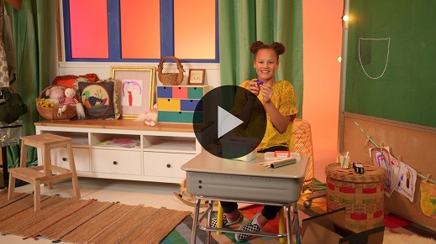

What a great Bible story! Have you ever had to move to a new place like Lizzy did? *(Group response)* Was it hard for you? *(Group response)* Sometimes starting over is very hard, but it’s nice to know that God is with us through it all. I’m glad God is in control of my life. Are you glad, too? *(Group response)*

**Response Time**

• *Play a worship song quietly*.

Today, we’ve learned that it’s good for God to be in control. He loves us, and wants the best for us. Sometimes things may seem a little crazy, or we may not understand why things are happening the way that they are. That’s okay. Even in those times, God knows what is best. Just like our Faith Verse taught us today, God’s thoughts are not like our thoughts. When you don’t know what’s going to happen, you can always trust God. He knows you, and He loves you. Let’s bow our heads and pray.

• *Optional: Have the kids repeat phrases of the prayer after you*.

|  |
| --- |
| Dear God, we know that You are in control. Sometimes we don’t understand what’s going to happen in our life, but we trust You. We know Your way isn’t always like our ways, but we choose for You to be in control. Thank You for loving us and always taking care of us. We love You. Amen. |

**Faith Verse**

Before we go, let’s review our Faith Verse. You’re really getting the hang of it. Let’s do the actions for what we’ve learned so far.

[Isaiah 55:8](https://ref.ly/logosref/Bible.Is55.8) (NLT)

“My thoughts are nothing like your thoughts,” says the Lord. “And my ways are far beyond anything you could imagine.”

• *Show the* ***Faith Verse Slide***.

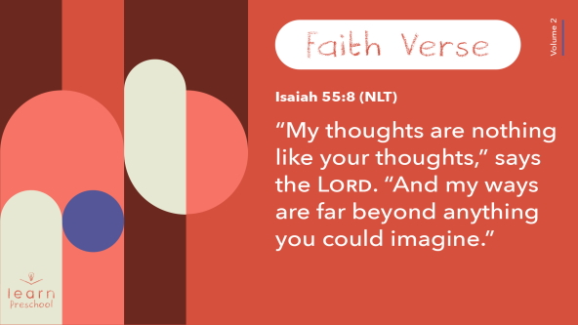

**Isaiah** *(hands at waist, spread apart, palms up and out)*

**55:** *(hands together like a clap)*

**8** *(hands opened to “book”)*

**“My thoughts** *(pointer fingers point to head)*

**are nothing** *(hands swoop down in a crisscross form)*

**like your thoughts,”** *(pointer fingers point to head)*

**says** *(pointer fingers to both sides of mouth)*

**the Lord**. *(pointer fingers point to the sky)*

Great job! Next time we’ll learn the rest of the verse.

**Closing**

Who can tell me something you learned today? *(Allow responses.)* Awesome! I love that we can come together and learn more about God and His Word. This week let’s remember our Faith Fact: **My God is in control**.

• *Play the* ***Faith Fact Sound*** *video (bell ringing)*.

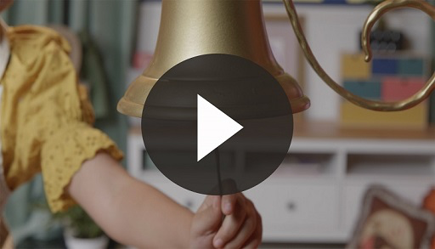

• *Show the* ***Faith Fact Slide.***



We can’t leave until we say our Faith Fact together one more time. Let’s see what my remote wants us to do. *(Hold pretend remote control.)* Oh no! It’s going crazy, it wants us to say it as quietly as we can while jumping up and down. Are you ready? *(Group response)* Here we go. *(Pretend to press remote.)* **My God is in control**.

**Dismissal to Small Groups**

Great job! Now it’s time to go to our circles where we’ll spend time in our very special small groups.

• *Dismiss the kids by groups*.

|  |
| --- |
| ***Leader Tip****: This can be done by assigning color teams or by age groups. Note that some young preschoolers may not know their age. Using a colored sticker, jersey, or wristband will help separate the kids and help identify their small groups.* |

**Small Group**

**25 Minutes**

*See supplies and prep instructions at beginning of session or in each activity below.*

|  |
| --- |
| ***Leader Tip****: Small groups can alternate to each circle, or all groups can do each activity at the same time. If you choose to alternate, you will need at least one leader per circle.* |

**Circle 1**

**Group Connection**

**Do You See What I See?**

|  |
| --- |
| ***You Will Need***   * *Blank paper, one sheet per kid plus extra* * *Markers or crayons*   ***Getting Ready***   * *Have a simple picture in mind for kids to draw (flower, stick figure, etc.).* * *Draw the picture to display to kids when they open their eyes.* |

Today, we’ll be artists and draw a masterpiece. If you’re ready say, “Oh yeah!” *(Group response)* Wait! Before you draw anything, I have to tell you one more thing that’s very important for you to do. While we’re drawing, you must follow my instructions very carefully. I will tell you exactly what to do, but I’m not going to tell you what we’re drawing. You’ll simply have to follow along. That’s sounds easy, right? *(Group response)* Let’s try it.

• *Give everyone a piece of paper and a crayon*.

• *Give instructions and demonstrate drawing a simple picture, such as a flower or a stick figure*.

Let’s look at our pictures. I know it was a little hard to draw exactly what I said to, but I love how hard you tried. I’m sure it was difficult and maybe a little frustrating at times since you didn’t know exactly what I was doing.

You did a great job trusting me and following my instructions. In fact, this reminds me of today’s Faith Verse. The way I had you draw the picture was maybe not the way you would have drawn it, but you trusted me. Our Faith Verse reminds us that the way God does things isn’t always the way we would, but we can trust Him, too. Let’s say it together.

[Isaiah 55:8](https://ref.ly/logosref/Bible.Is55.8) (NLT)

“My thoughts are nothing like your thoughts,” says the Lord. “And my ways are far beyond anything you could imagine.”

God knows exactly what’s best for us. We get what’s best when we let Him be in control. It may not always be easy, but God knows what is best. It’s good news when we can say our Faith Fact and mean it. **My God is in control.**

**Circle 2**

**Activity Page Time**

**In Control**

|  |
| --- |
| ***You Will Need***   * ***Small Group Activity Page****, one per kid* * *Markers or crayons*   ***Getting Ready***   * *Print copies of the* ***Small Group Activity Page****, one per kid.* |

Did you know lots of things can be controlled? For example, who controls you and tells you what to do? *(Allow responses.)* On our Activity Page, there are different things that need help being matched up with their controller. Take your time and draw lines between the controller and the thing being controlled.

• *Give kids the* ***Small Group Activity Page*** *and crayons or markers*.

What did you match up? *(Allow responses.)* As you color the pictures, let’s talk some more about control. What is something we can control in our life?

• *Guide the kids to mention deeper things like the words we say, how we act, and our attitudes*.

Who do we want to be in control of our life? *(Allow responses.)* How can we show God that we’ve given Him control of our life? *(Allow responses.)* There are so many ways to let Him lead us.

You did a fantastic job connecting those controllers back to their objects. It makes everything work a lot better when they’re connected right. Did you know our life is much better when we are connected to the One who controls everything? When we trust God and stay connected to Him, it makes everything so much better.

• *During the activity, interrupt and practice the Faith Fact:* **My God is in control.**

• *Play* ***Faith Fact Sound*** *video****.*** *Review the Faith Fact even if you can’t play the sound*.



**Circle 3**

**Feet-to-Floor Game Time**

**Maze Craze**

|  |
| --- |
| ***You Will Need***   * *Painter’s tape or other floor-safe tape* * *Cones or floor markers*   ***Getting Ready***   * *Tape lines across the floor. Have one line that makes it all the way across the room, and several that dead end. Have cones at the start and end of the maze so kids know where the finish line is.* |

You’ve been such great listeners today. Now, it’s time to get on our feet and get moving. I’m sure you saw the crazy lines on the floor. Maybe you were wondering what they are for. Welcome to the Maze Craze.

Today, your goal is to make it through the maze as quickly as you can. As you go through the maze, I’ll be giving you instructions on how to do it. Let’s practice. I might say something like, “Hop on two feet.” *(Group response)* Maybe I’ll say, “March like a solider.” *(Group response)* Make sure you’re listening closely so you know what you’re supposed to do. Are you ready? *(Group response)*

• *Have kids make a single line and let them go through the maze one at a time as you change up the actions*.

• *Optional: Consider timing each kid to see who can make it through the fastest*.

• *If time allows, let kids take turns being in control and giving the instructions*.

Wow! You did a great job making it through that Maze Craze. You made your way through by listening and following instructions. You trusted me and did what I asked you to do. We made it through together. That reminds me of our Faith Verse. Let’s say it together.

[Isaiah 55:8](https://ref.ly/logosref/Bible.Is55.8) (NLT)

“My thoughts are nothing like your thoughts,” says the Lord. “And my ways are far beyond anything you could imagine.”

God knows everything. As long as we trust Him to be in control, He will get us to right place every time.

**Circle 4**

**Hands-On Learning**

**Play Dough Smash Up**

|  |
| --- |
| ***You Will Need***   * *Play dough for each kid*   *No prep needed for this activity.* |

In our Bible story, the potter was making something with clay. Now, you’re going to be the potter and create something. Keep creating until I tell you to stop.

• *Give kids a minute or two to create. Then, say stop and have them take their hands away from the play dough*.

Let’s look at what you’ve created so far. Raise your hand if you like what you’re making. *(Group response.)* In our Bible story, what did the potter do when he didn’t like what he created? *(Allow responses.)*

You’re the potter, so you’re in control. If you don’t like what you’re making, smash it and start over. If you do like what you are making, keep right on working. You’re in charge.

• *Allow kids to keep working with the play dough until time runs out*.

**Dismissal**

• *Play the* ***Faith Fact Sound*** *video (bell ringing)*.



• *Show the* ***Faith Fact Slide.***



Hey! Do you know what that sound means? *(Group response)* It’s time to say our Faith Fact! Say it with me in a loud and happy voice. **My God is in control.** Great job! Now let’s say it in a tiny mouse voice. **My God is in control.**

You’re awesome! I’m so glad God created each one of you. I can’t wait to see what we get to learn about God together next time.

• *Send home the* ***Small Group Activity Page*** *and the Circle 1 drawing with each kid*.

• *Remind parents that there are* ***Family Devotions*** *available on the app to do with their kid*.

• *Tell everyone the date and time for the next session*.